**The Historical Role of Capitalism in Shaping Environmental Justice: A Study of Economic Growth and CO2 Emissions from 2000 to 2020**

(the google doc link: <https://docs.google.com/document/d/1FbwtfXazCsxv7iaRTbtH46DdCo2K6A4YRFbQxONU7dg/edit?usp=sharing>)

**Introduction**

Environmental injustice has become a significant issue in the global conversation about climate change. While there is widespread recognition of the need to reduce emissions and address global warming, the debate often stalls when it comes to determining who should bear the costs. This issue arises because the responsibility for climate change is not equally distributed. The countries that have historically emitted the most pollutants are not always the ones most affected by the consequences. In fact, the brunt of climate change often falls on underdeveloped countries that lack the advanced technology and resources to deal with its effects. This uneven distribution of responsibility highlights the unequal nature of climate change and its consequences. In response, the research aims to examine the historical incentives that capitalism has played in shaping environmental progress, particularly in relation to economic growth and CO2 emissions. The study will focus on three groups of countries—low-income countries, newly industrialized nations, and developed countries—to explore how economic growth has influenced emissions patterns within each group. By analyzing these different groups, the research seeks to uncover the complex relationship between economic development and environmental responsibility, as well as to highlight the inequalities that persist in the global response to climate change.

The data used for CO2 emissions are sourced from EIA World Data, which is provided by the U.S. Energy Information Administration (EIA). For GDP data by country, the source is the World Bank Open Data, which includes datasets on various aspects of development, such as economic growth and the environment. The GDP figures have been adjusted using the price index from the Consumer Price Index (CPI-U), provided by the U.S. Department of Labor Bureau of Labor Statistics. The datasets cover the period from 2000 to 2020.

**Capitalism's Role in Environmental Injustice**

Economic incentives drive technological efficiency in resource extraction, significantly altering Earth's systems. In the 19th century, steam technology thrived due to British imperialism and global exploitation. The rationale for these advancements was "geared to the opportunities provided by the constellation of a largely depopulated New World" (Malm & Hornborg, 2014). The decline of Indigenous populations left uncultivated lands for European settlers to control resource-rich territories. This created a need for improved production capabilities that steam-powered factories could provide. However, increased extraction efficiency leads to amplified consumption and environmental impact. Modern societies' dependence on technology can "modify the very core processes that drive Earth System dynamics" (López-Corona & Magallanes-Guijón, 2020). Thus, the pursuit of economic profit has historically fueled technological progress in resource over-extraction.

The unequal allocation of resources has exacerbated global inequality through technological development. Limited access to innovations for a wealthy minority prevents equitable distribution of benefits. In capitalist systems, scientific progress “could only be installed by the owners of the means of production” (Malm & Hornborg, 2014). Thus, a privileged class drives environmental exploitation through systematic inequality, leaving the marginalized unaccountable. Similarly, the global technological gap is “predicated on a global division of labour that is geared precisely to abysmal price and wage differences between populations” (Malm & Hornborg, 2014). Scientific prosperity in wealthy nations relies on the exploitation of cheaper labour in less affluent countries. Lacking financial resources to invest in skilled labour, developing nations depend on outdated technologies that hinder growth. Consequently, “[p]erceptions of ‘technology’ [...] are cultural constructions conditioned by global power structures” (Malm & Hornborg, 2014). Companies with advanced technologies decide which innovations to pursue and promote in favour of the wealthy. Economic disparity thus ensures that the benefits of advanced industries accrue to a small group of nations while leaving others disadvantaged.

**Classifying Countries Based on GDP Growth**

The analysis focuses on three groups of countries to evaluate the differing impacts of CO2 emissions and economic growth: low-income countries, newly industrialized countries (NICs) and developed countries. GDP growth is utilized as the basis for classifying countries into these categories. Countries with an average GDP growth of less than 10% over a span of 22 years and ranking each year among the top 10% globally in GDP are classified as developed countries. Countries with GDP growth exceeding 10% over the same period are categorized as newly industrialized countries. Meanwhile, countries with GDP growth below 10% and a consistent ranking in the bottom 11% of global GDP each year are classified as low-income countries.

During the classification process, Mexico met the criteria for developed countries. However, existing literature indicates that this classification does not align with the study’s framework, leading to its exclusion. This results in the identification of eight developed countries: Canada, the European Union, France, Germany, Italy, Japan, the United Kingdom and the United States. For the NIC category, while more than eight countries were eligible, only the top eight with the highest average GDP growth were included to maintain balance across the categories. These countries are Chad, China, Equatorial Guinea, Ethiopia, Ghana, Guyana, Iraq, and the Maldives. In identifying low-income countries, the bottom 10% of GDP rankings initially included Tuvalu. However, due to significant missing data for Tuvalu during the study period, the threshold was adjusted to the bottom 11% of GDP rankings. This adjustment resulted in the selection of the following low-income countries: Belize, Burundi, the Central African Republic, Eswatini, Kiribati, Lesotho, Samoa and Seychelles.

**Trends in Emissions and Economic Growth Across Country Groups**

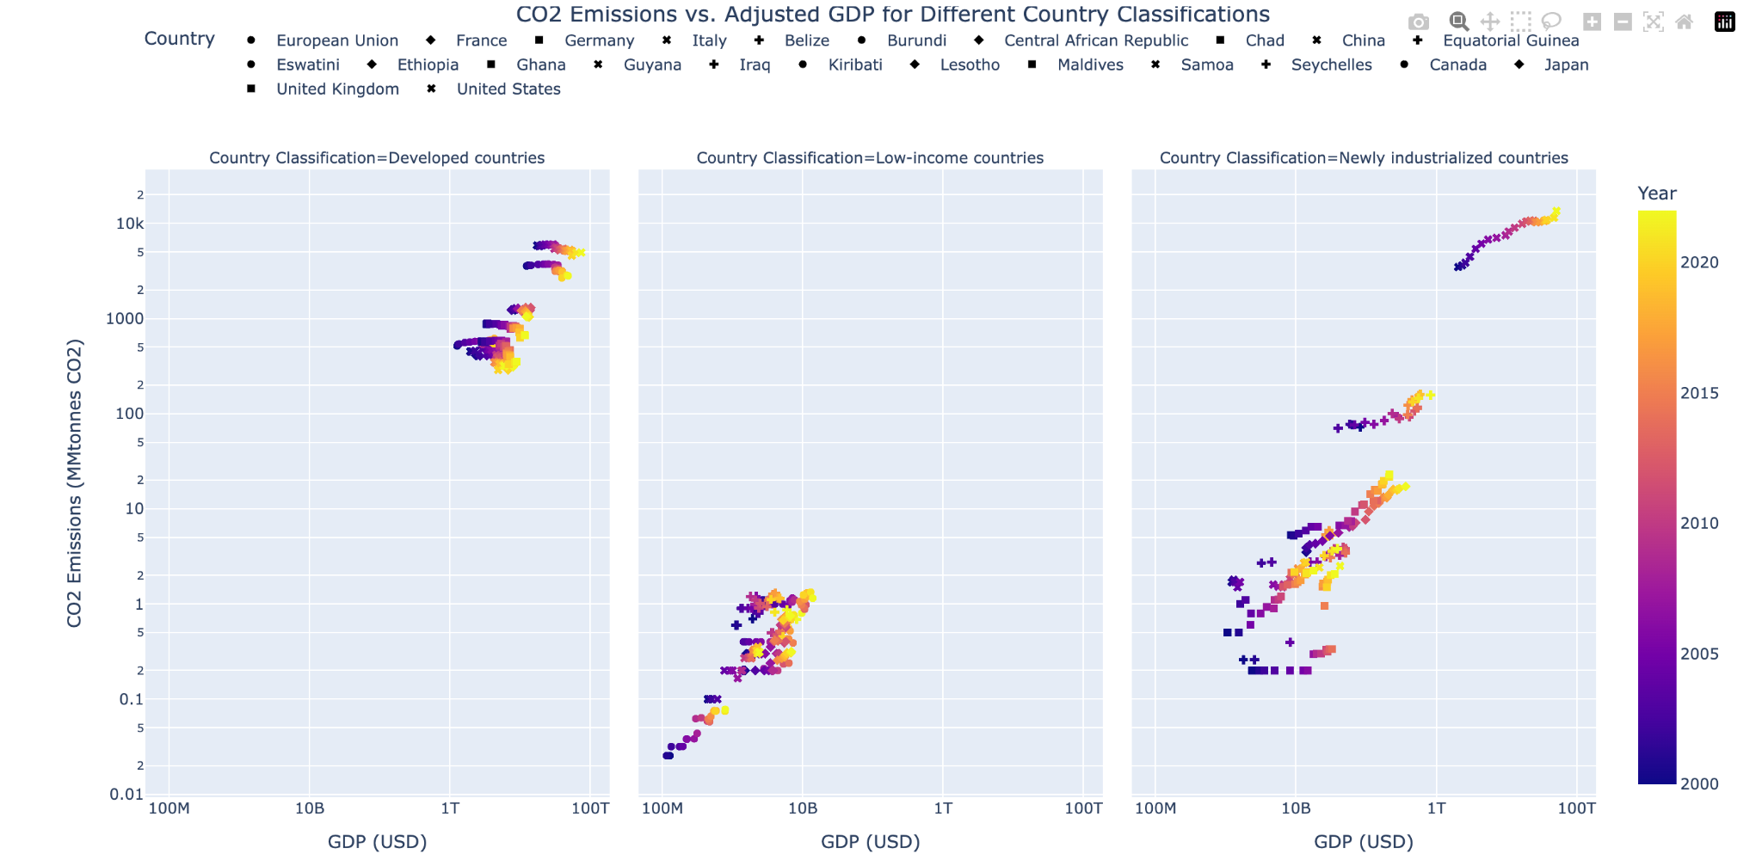

In developed countries, as GDP increases, the data shows an overall trend of decreasing emissions. This phenomenon suggests that “marginal impacts of economic growth on carbon emissions decline as average income increases”(Ravallion et al., 2000). For instance, developed countries' emissions appear to decrease within their borders (territorial emissions) because production and the associated emissions are outsourced to lower-income countries (consumption emissions). It reflects the dynamic where production, and its environmental costs, are offloaded to less developed regions to sustain consumption patterns in wealthier states (Soener, 2019).

For both NICs and low-income countries, it shows an upward trend, where an increase in GDP is associated with a rise in emissions. For these countries, the focus on economic growth outweighs environmental concerns, which pushed them to undergo rapid industrialization. The environmental impact of coal, particularly its contribution to CO2 emissions and local air pollution, is often a secondary concern for these countries. Although coal is a more significant source of pollution compared to other energy sources, “the concern is often of secondary importance to many people in developing countries living in utter poverty" (Mikulska, 2019). The lack of access to clean energy, food and healthcare makes it difficult for the public to prioritize long-term environmental issues over immediate economic and energy needs. As Mikulska (2019) highlights, "in developed countries, wealthy populations are more likely to express their preferences for clean environment (water, air, food) and climate change," but this is not the case in developing nations, where energy security and development take precedence. Thus, low-income counties and NICs prioritize industrialization and economic growth over environmental considerations, and the transition to cleaner energy sources remains a challenging task.

For low-income countries, the tightly clustered points in the data suggest these countries generally exhibit lower economic output and lower levels of emissions, creating a dense grouping in the lower-left corner of the logarithmic plot. The limited variability in economic and industrial activity could explain this clustering. Low-income countries often have more homogenous economies, typically driven by subsistence agriculture or small-scale industries (Angelsen et al., 2014). On the other side, NICs values are more dispersed which implies varying levels of emissions depending on their stage of industrial growth and dependence on energy-intensive industries. The variation in emissions could reflect differences in energy policies, resource availability and the adoption of technologies across NICs. While most NICs show an upward trend, the relationship is more variable. NICs are in a transitional phase, striving to balance industrial growth with environmental sustainability. These countries exhibit a broad spectrum of industrial capabilities, from heavy manufacturing to advanced technology sectors, contributing to the greater dispersion of data points.

**Variation in GDP Growth and Emissions Across NICs**

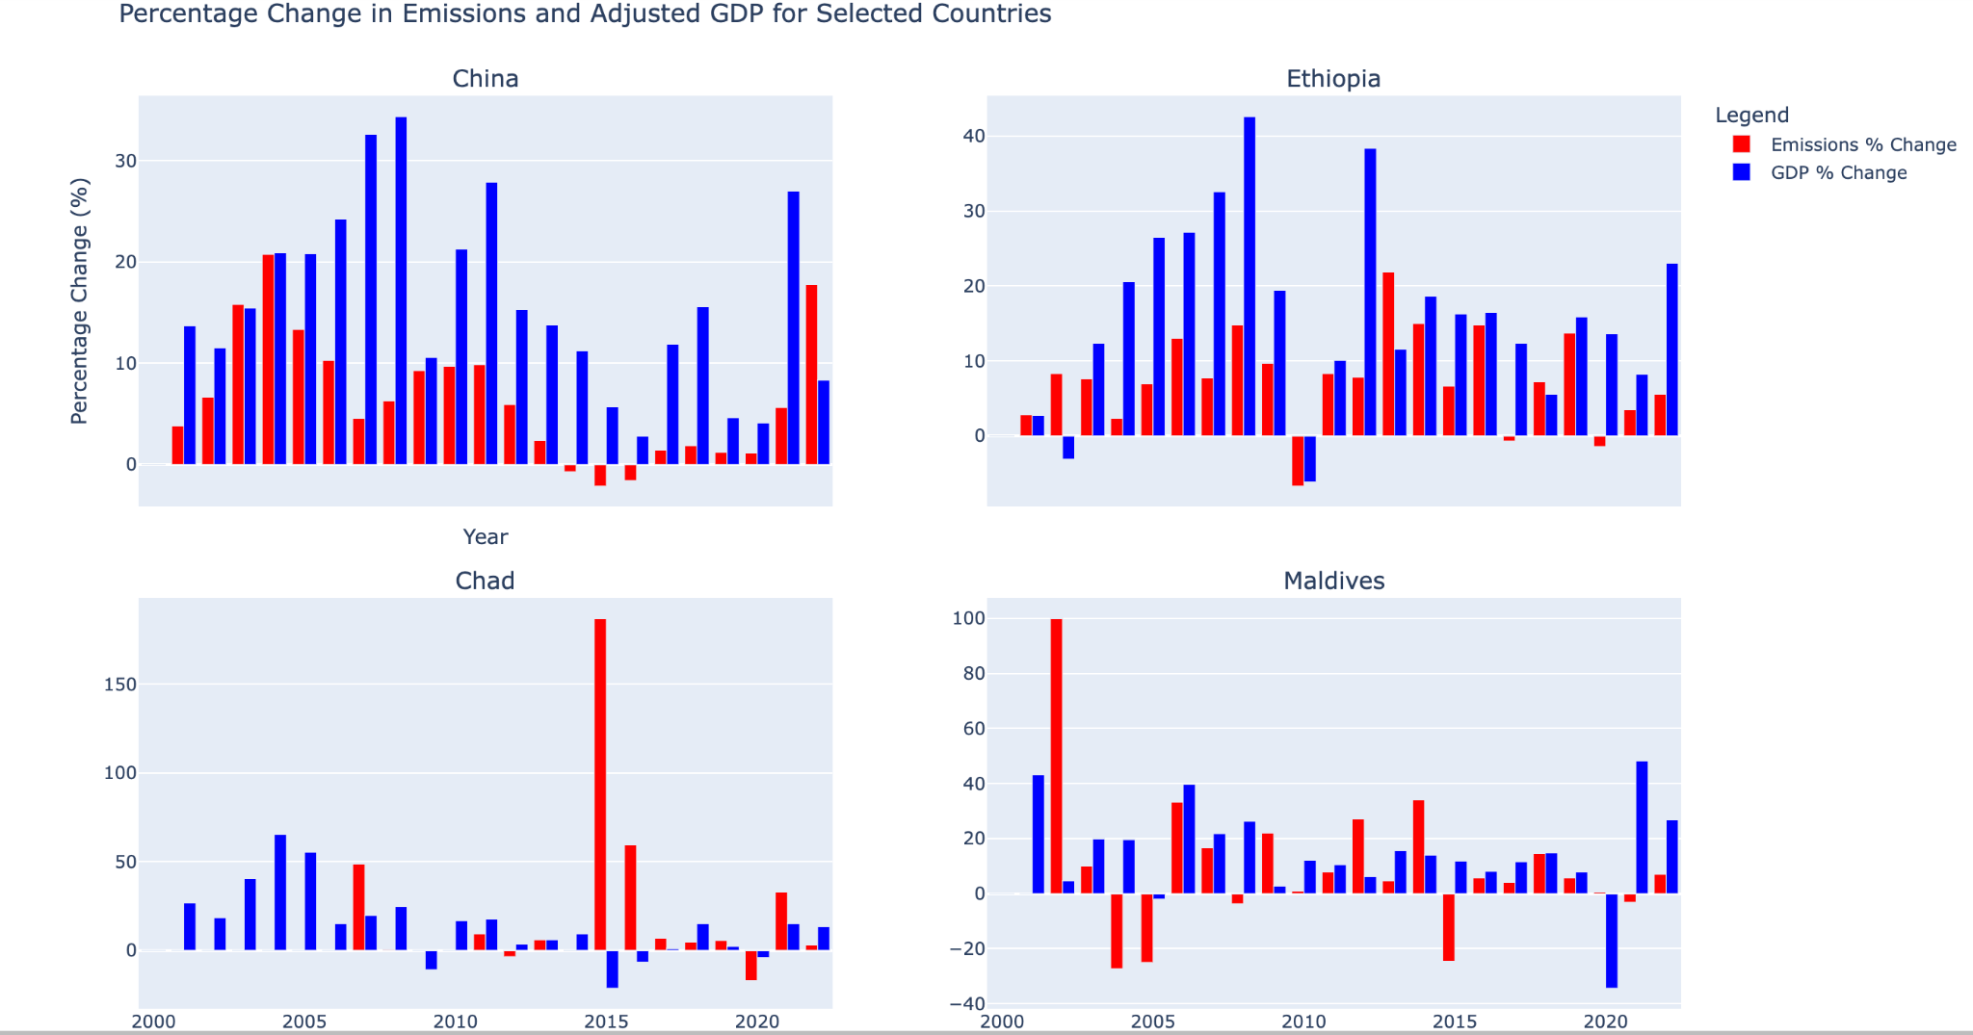

Variations in energy policies, resource availability and the adoption of technologies influence different NICs, resulting in diverse rates of GDP growth and increases in emissions. For example, China and Ethiopia have shown significant growth in both GDP and emissions over time, largely influenced by China's Belt and Road Initiative (BRI), which has driven robust economic expansion. This economic development has directly impacted both nations through large-scale infrastructure investments, trade agreements and innovation projects that stimulate economic activity.

China's strategic investments in Ethiopia have not only bolstered the latter's economic growth but have also led to increased demand for energy, a primary driver of emissions. Bharti (2023) notes that “regional imbalances come in the way of development, and the rate of production is continuously increasing after the BRI projects in Ethiopia,” leading to increased industrial activity and emissions. This pattern is similarly observed in China, where economic expansion through global investments has triggered both GDP growth and a rise in emissions, as industries ramp up production and energy consumption to meet global demand spurred by BRI projects. Conversely, countries like Chad and Ghana exhibit slower growth in both GDP and emissions, despite being part of the same partnership. This disparity may result from various factors, such as differences in economic structures, lower energy consumption or the adoption of more sustainable practices. Further research is needed to fully understand why newly industrialized countries experience such varying rates of GDP growth and emissions increase.

**China's GDP Growth and Emissions vs. Low-Income Countries' Energy-Driven Growth**

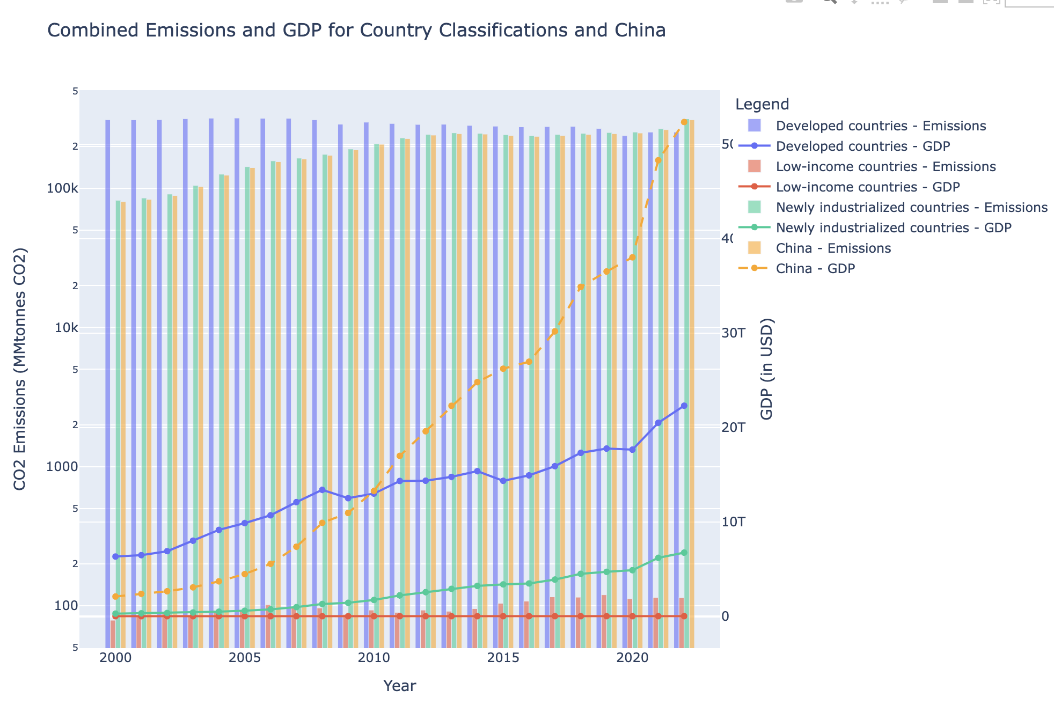

While most NICs show a positive correlation, where an increase in GDP leads to an increase in emissions, China exhibits a much stronger connection. For instance, China is responsible for the majority of the total emissions. Yuan et al. (2014) demonstrate that in China, income and energy consumption are interconnected through a bilateral Granger causality, while emissions exhibit a unilateral causality influencing income. This indicates that China's rapid economic growth and energy consumption are heavily related to its emissions growth, contrasting with the less pronounced relationships observed in other NICs.

On the other hand, for low-income countries, the rise in emissions is more pronounced than the increase in GDP. This can be attributed to their heavy reliance on energy-intensive resources, meaning that while their economic growth may not be as pronounced, emissions increase significantly due to energy consumption. Many low-income countries rely heavily on fossil fuels, particularly coal, for industrial activities due to a combination of economic, technological and resource constraints. As Mikulska (2019) highlights, coal is the cheapest energy source for many developing nations and is often more accessible than alternatives. Furthermore, coal mining is a labor-intensive industry, providing employment opportunities in these regions where cheap labor is abundant due to booming populations. As a result, without a major technological breakthrough or significant policy intervention, these countries will continue to rely on fossil fuels for their energy needs and industrial activities. While fossil fuel consumption may temporarily enrich economies, especially in industrialized nations, it may not support sustained growth. In some cases, nations relying heavily on fossil fuels face long-term economic risks due to environmental degradation and the eventual necessity to shift towards cleaner, more sustainable energy sources (Bhuiyan et al., 2022).

**Energy Intensity Trends**

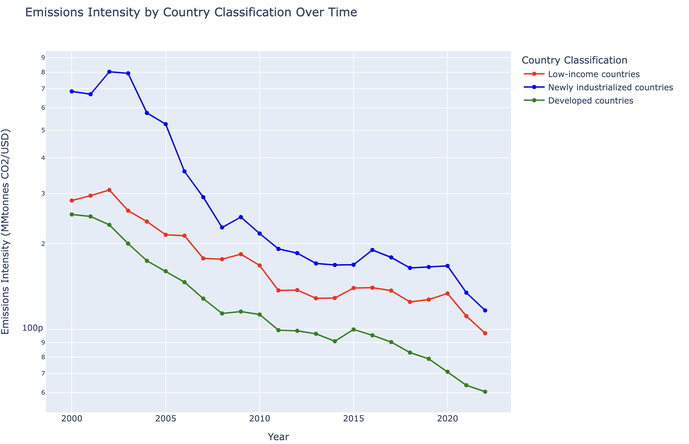

Based on the importance of renewable energy, the energy intensity ratio is presented for the three groups of countries. It is important to understand the concept of energy intensity, which is the ratio of emissions to GDP, essentially providing a measure of how much emissions are produced per dollar of economic output. Energy intensity reflects how efficiently a country uses energy to generate economic value. A lower energy intensity indicates that less energy is required to produce each unit of economic output, which is a sign of improving energy efficiency (Energy.gov, 2016). The graph suggests that, for each group of countries, the energy intensity ratio is decreasing, potentially indicating that energy efficiency is improving. However, further research is needed to determine whether this decline in energy intensity is primarily due to decreasing emissions or increasing GDP. This will help to better assess whether countries are truly becoming more energy-efficient on a global scale.

Developed countries, due to their access to more renewable energy, are the most energy-efficient, followed by low-income countries. As a country attains higher income levels, emissions resulting from consumption may turn into “an inferior good as a result of preferences for a cleaner environment at higher levels of income” (Barassi & Spagnolo, 2012). Preference for greener technology encourages developed countries to invest in technological innovations aimed at reducing CO2 emissions. Research and development (R&D) investments often focus on implementing sustainable practices (Apanasovich & Apanasovich, 2024). Thus, countries with higher GDP and R&D spending tend to exhibit decreased CO2 emissions over time, suggesting that advancements in technology and efficient practices are integral to this trend.

Renewable energy also offers a path to sustainable growth. As countries shift towards more renewable sources, they can potentially decouple economic growth from fossil fuel reliance, ensuring long-term development without the negative environmental impact (Bhuiyan et al., 2022). However, low-income countries and NICs face challenges in transitioning to greener resources and meeting global climate goals due to limited financial resources and technology. They lack the means to integrate widespread use of renewable energy into their industries. While renewable energy technologies like solar power are "already far cheaper," developing nations still struggle with scaling them due to "intermittency" and the high costs of energy storage solutions (Tongia, 2022). As such, reliance on fossil fuels remains essential in the short term. Therefore, low-income countries and NICs are less likely to adopt renewable energy alternatives to replace fossil fuels, leading to higher energy intensity.

**Conclusion**

The relationship between economic growth, technological progress and CO2 emissions highlights the unequal distribution of responsibility for climate change. Developed countries, with their advanced technologies and access to renewable energy, show a trend of decreasing emissions as their economies grow. In contrast, low-income countries and newly industrialized nations prioritize economic growth, often at the expense of environmental sustainability, leading to rising emissions. The trade-off between economic growth and climate change presents a complex challenge, particularly for developing countries. While reducing emissions is critical to mitigating the impacts of climate change, it is unfair to demand that developing nations immediately curb their emissions. Historically, these countries have contributed far less to global emissions compared to their developed counterparts. The recent surge in emissions from developing nations can largely be attributed to their economic growth, which is still heavily reliant on fossil fuels for industrialization. Developed countries, having industrialized early, had access to cleaner technologies and renewable energy sources. Consequently, expecting rapid shifts to renewable energy in developing countries is unrealistic, given the limited financial resources, technological infrastructure and institutional capacity they face.

Some may argue that wealth redistribution could offer a solution by providing developing countries with the resources to transition to cleaner energy. While this could potentially alleviate some immediate financial barriers, it would not address the underlying structural drivers of emissions. If these countries are still economically incentivized to produce goods cheaply, often through high-emission energy sources, a redistribution of wealth would likely only serve as a bandage rather than a long-term solution. Without altering the economic incentives that drive emissions growth, even wealth redistribution will not halt environmental degradation. Low-income countries, in particular, may simply escalate their production efforts to catch up economically, continuing the cycle of rising emissions. Therefore, addressing the root causes of emissions requires more than just wealth redistribution—it necessitates a fundamental shift in the structural drivers of economic growth, energy consumption and technological advancement to create a sustainable future for all nations.

Works Cited

Apanasovich, N., & Apanasovich, T. (2024, April 8). *The impact of technological innovations and economic growth on carbon dioxide emissions*. FREE NETWORK. https://freepolicybriefs.org/2024/04/08/economic-growth-co2-emissions/

Angelsen, A., Jagger, P., Babigumira, R., Belcher, B., Hogarth, N. J., Wunder, S., Smith-Hall, C., Börner, J., & Bauch, S. (2014). Environmental income and rural livelihoods: A global comparative analysis. *Environmental Income and Rural Livelihoods: A Global Comparative Analysis*. <https://www.sciencedirect.com/science/article/pii/S0305750X14000722>

Barassi, M. R., & Spagnolo, N. (2012). Linear and Non-linear Causality between CO₂ Emissions and Economic Growth. *The Energy Journal*, *33*(3), 23–38. <http://www.jstor.org/stable/23268093>

Bharti, M. S. (2023). The Sustainable Development and economic impact of China’s belt and road initiative in Ethiopia. *East Asia*, *40*(2), 175–194. https://link.springer.com/article/10.1007/s12140-023-09402-y

Bhuiyan, M. A., Zhang, Q., Khare, V., Mikhaylov, A., Pinter, G., & Huang, X. (2022). Renewable Energy Consumption and Economic Growth Nexus—A Systematic Literature Review. *Frontiers in Environmental Science*, *10*. https://doi.org/10.3389/fenvs.2022.878394

*INTERACTIVE: Energy intensity and carbon intensity by the numbers*. (n.d.). Energy.gov. https://www.energy.gov/articles/interactive-energy-intensity-and-carbon-intensity-numbers

López-Corona, O., & Magallanes-Guijón, G. (2020, June 8). *It is not an anthropocene; it is really the technocene: Names matter in decision making under planetary crisis*. Frontiers. https://www.frontiersin.org/journals/ecology-and-evolution/articles/10.3389/fevo.2020.00214/full

Malm, A., & Hornborg, A. (2014). The geology of mankind? A critique of the anthropocene narrative. *The Anthropocene Review*, *1*(1), 62–69. https://journals.sagepub.com/doi/10.1177/2053019613516291

Mikulska, A. (2019, April 1). *The long goodbye: Why some nations can’t kick the coal habit*. Kleinman Center for Energy Policy. https://kleinmanenergy.upenn.edu/research/publications/the-long-goodbye-why-some-nations-cant-kick-the-coal-habit/#:~:text=Without%20a%20major%20technological%20breakthrough,China%20(IEA%202018a)%20being%20the

Ravallion, M., Heil, M., & Jalan, J. (2000). Carbon Emissions and Income Inequality. *Oxford Economic Papers*, *52*(4), 651–669. <http://www.jstor.org/stable/3488662>

Soener, M. (2019). Profiting in a Warming World: Investigating the Link Between Greenhouse Gas Emissions and Capitalist Profitability in OECD States. *Sociological Forum*, *34*(4), 974–998. <https://www.jstor.org/stable/48558583>

Tongia, R. (2022, October 26). *It is unfair to push poor countries to reach zero carbon emissions too early*. Brookings. https://www.brookings.edu/articles/it-is-unfair-to-push-poor-countries-to-reach-zero-carbon-emissions-too-early/

Yuan, J., Xu, Y., & Zhang, X. (2014). Income Growth, Energy Consumption, and Carbon Emissions: The Case of China. *Emerging Markets Finance & Trade*, *50*(5), 169–181. http://www.jstor.org/stable/24475776